1. 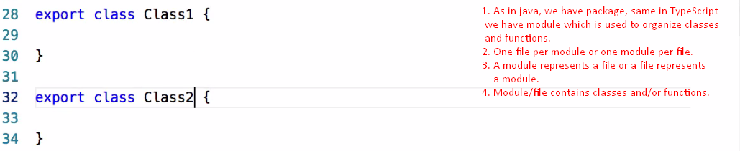
2. Now, we want to use some class from other module.
3. Java import and ES6 import are same.
4. 
5. 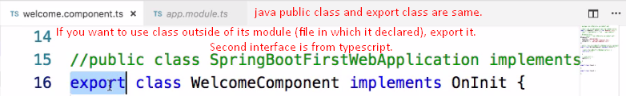
6. 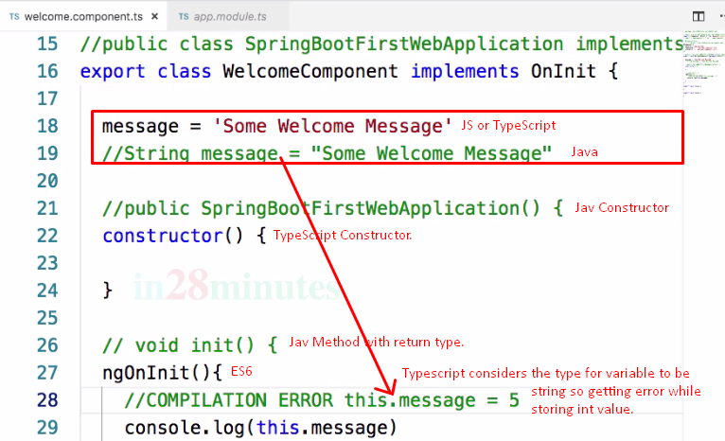
7. 